AI Waste Segregation Model

Project Overview
This project is an offline-first, local computer vision system built to automate municipal solid waste segregation, weight estimation, and bin sorting recommendations. The main problem it solves is the high latency, cost, and privacy concerns of cloud-based visual APIs. By migrating the intelligence locally, the system performs real-time classification on edge devices without requiring an internet connection.
It detects discarded items using a fine-tuned, CPU-optimized YOLOv11 model, cross-references detections with a local Excel spreadsheet database to append exact unit weights and material types, and suggests the correct sorting bin (Wet, Dry, Medical, or Electronic). The system runs through a glassmorphic web dashboard that supports direct webcam streams, drag-and-drop image uploads, client-side Non-Maximum Suppression (NMS), persistent stats tracking via browser memory, and a lightweight client-side TensorFlow.js model fallback.

Tech Stack
Layer | Tools Used | What It Does
Frontend | HTML5, CSS3, Vanilla ES6+, Canvas API, Lucide Icons | Responsive dashboard UI, camera stream capture, bounding box rendering, client-side NMS, and localStorage stats telemetry.
Backend | Python, Flask, Flask-CORS, UUID | Lightweight local REST API, thread-safe temp file IO, and coordinates backend operations.
Data Layer | Pandas, OpenPyXL, Microsoft Excel | Read and parse target weights, categories, and material metrics from waste_dataset.xlsx.
Deep Learning | Ultralytics YOLOv11, PyTorch, TensorFlow.js | Local real-time object detection inference (via PyTorch) and client-side classification fallback (via TF.js).

Deep Learning Models
YOLOv11n — Object Detection & Bounding-Box Regression
The primary model is a YOLOv11 Nano (or YOLOv11s Small) architecture, fine-tuned via transfer learning on a custom waste classification dataset at $640×640$ resolution. It is configured to detect 36 distinct waste classes (such as plastic bottles, batteries, apple waste, and syringes). Standard post-processing extracts box centers ($xywh$), confidence indices, and class classifications on the local CPU or GPU.
Teachable Machine — Client-Side TensorFlow.js Classifier
This is a lightweight convolutional image classifier loaded directly in the browser using tfjs. It acts as a fallback model when the local Flask server is offline.

Data Collection & Training
The project uses an original dataset compiled from real-world photographs of household and medical waste items. These images were annotated manually using the Roboflow annotation suite (defining 36 object classes), split into train, valid, and test datasets, and exported in standard YOLO format.
Using PyTorch and the Ultralytics framework, transfer learning was performed on pretrained yolo11n.pt weights. Training was executed locally on CPU/GPU hardware for 50 epochs with a batch size of 16, utilizing standard data augmentations:
- Mosaic Data Augmentation: mosaic=1.0 (combines 4 images to improve multi-object detection).
- Scaling & Translation: scale=0.5 (scales images by $±50\%$).
- Horizontal Flips: fliplr=0.5.
- Random Erasing: erasing=0.4.
The finalized weights were saved as best.pt and also exported to best.onnx to optimize CPU-only inference speeds.

Computer Vision Pipeline
The inference pipeline coordinates processing steps across the local backend and browser client:
- Step 1: Ingestion & Temp Buffering: The frontend uploads an image file or camera snapshot to the Flask backend. The server writes the file to the local system temp folder using a random UUID filename (e.g., a7d8...f3.jpg) to avoid file write locks on Windows.
- Step 2: YOLOv11 Forward Pass: The PyTorch YOLOv11 engine loads the temp image, executes forward propagation, and returns absolute bounding boxes ($xywh$), prediction scores, and class labels.
- Step 3: Excel Enrichment Lookup: The backend normalizes the labels (e.g. converting tomato_waste or papers to standard normalized tokens) and searches waste_dataset.xlsx. It retrieves specific physical weights (in grams), recommended bin classes, and material compounds (e.g., "PET Plastic", "Latex"). Unmatched items fallback to hardcoded Python dictionaries.
- Step 4: Client-Side Non-Maximum Suppression (NMS): The frontend receives the raw detections and runs NMS ($IoU=0.35$, containment threshold $=0.75$) in JavaScript to prune overlapping boxes of the same category, removing visual clutter.
- Step 5: Telemetry & Canvas Rendering: Detections are drawn as labeled bounding boxes colored by category (Green for Wet, Blue for Dry, Red for Medical, Yellow for E-waste). The statistics card adds the weights to localStorage and estimates total CO₂ offsets (multiplying weight by $0.45\text{g}$).

Workflow
FrontendCaptureAndPreprocessing {
Workflow:
1. Capture stream/file and load it into Canvas context.
2. Scale preview image to maintain aspect ratio on Canvas.
3. Convert canvas frames to JPEG blobs.
4. Append image blob and confidence values to a multipart FormData payload.
Main Functions:
- navigator.mediaDevices.getUserMedia()
- canvas.getContext("2d") / canvas.toBlob()
- FormData.append()
Math Formulas:
- scale_factor = min(width_canvas / width_image, height_canvas / height_image)
- offset_x = (width_canvas - width_image * scale_factor) / 2
- offset_y = (height_canvas - height_image * scale_factor) / 2
}

BackendAPIAndStorage {
Workflow:
1. Receive image file via Flask POST request and validate request field.
2. Generate lock-free temporary filename using UUID.
3. Write image payload to system temporary folder.
4. Delete physical temporary file after processing to free disk space.
Main Functions:
- CORS(app)
- tempfile.gettempdir() / uuid.uuid4().hex
- image.save() / os.remove()
Math Formulas:
- conf_threshold = float(val) if (0.0 <= float(val) <= 1.0) else 0.20
}

InferenceAndPrediction {
Workflow:
1. Pass temp file to local YOLOv11 engine for object detection.
2. Extract bounding boxes, class labels, and confidence scores.
3. If backend is offline, load browser Teachable Machine fallback.
4. Resize canvas frames to 224x224 and predict macro class via WebGL.
Main Functions:
- YOLO() / model.predict()
- tmImage.load() / model.predict(canvas)
Math Formulas:
- Box coordinates: x_min = x_center - w/2, y_min = y_center - h/2
- Softmax probability: P(class_i) = exp(z_i) / sum(exp(z_j))
}

DataEnrichmentAndDBLookup {
Workflow:
1. Load waste_dataset.xlsx via pandas and normalize label strings.
2. Match predicted class names to database records.
3. If matched, assign weight, category, and material type properties.
4. If unmatched, resolve attributes using dictionary fallback lookups.
Main Functions:
- pd.read_excel()
- normalize_name() / df.iterrows()
- get_weight_fallback() / get_material_type_fallback()
Math Formulas:
- normalize(x) = replace(lower(x), ["_", " "]) \ "s" (except "glass")
- Weight_total = sum(Weight_k)
}

PostProcessingAndTelemetry {
Workflow:
1. Sort predictions descending and run client-side NMS to prune duplicates.
2. Render overlay boxes on the visual Canvas colored by category.
3. Save cumulative counts, weights, and carbon metrics to localStorage.
Main Functions:
- applyNMS(predictions, iouThreshold)
- localStorage.setItem() / localStorage.getItem()
- updateSortingGuide() / renderStats()
Math Formulas:
- IoU(A, B) = Area(A ∩ B) / Area(A ∪ B)
- containment(A, B) = Area(A ∩ B) / min(Area(A), Area(B))
- CO2_Offset = Weight_total * 0.45
}

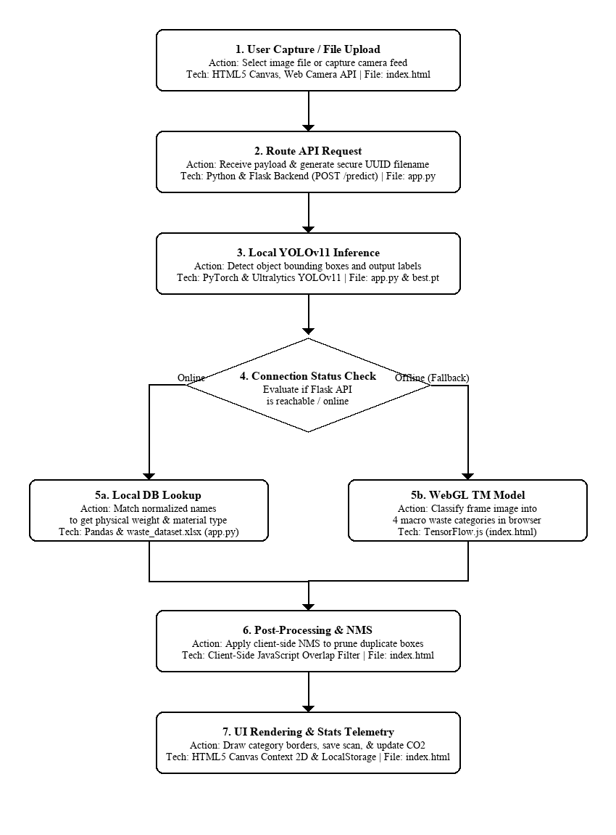
CONCLUSION
This project successfully implemented an offline, local AI Smart Waste Segregation Hub combining YOLOv11 and a Flask backend to automatically classify 36 waste classes into 4 main categories (Wet, Dry, Medical, Electronic).
By integrating a local Excel database and a client-side TensorFlow.js fallback model, the system operates with low latency, high uptime, and full data privacy. It provides real-time sorting recommendations and logs cumulative statistics and CO₂ offsets to browser memory, proving the viability of offline edge computing in waste management.

FUTURE SCOPE
- Hardware & IoT Integration: Connect the model output to an Arduino/micro-servo system to physically route waste into automated bin compartments.
- Edge Device Optimization: Quantize the YOLOv11 model (INT8 compression) to run on low-power, standalone microcomputers like a Raspberry Pi 5.
- Real-Time Video Tracking: Upgrade the image upload pipeline to process continuous video streams on moving recycling conveyor belts.
- Dataset Scaling: Expand the model to classify more materials (e.g., specific plastic polymers) and set up an active learning retraining pipeline.

